

Palestine Technical University – Kadoorie

Faculty of Engineering and Technology

Computer Systems Engineering Department

Course Name:

Graduation Project

Project Title:

**BLOOD PRESSURE HEALTH TRACKER USING AI**

Prepared by:

Adham Abu Hantash - 201911415

Batool Nawasra - 201910880

Razan Harasha - 201910501

Saeed Sabra - 201911319

Supervisor:

Dr. Yousef Daraghmeh

Tulkarem, Palestine

Feb 4, 2024

**Table of Contents**

Chapter 1: Introduction 3

1.1 Overview: 3

1.2 Introduction: 4

1.3 The Problem Description: 5

1.4 The Solution: 5

1.5 Objectives: 6

1.6 Data Sets: 7

1.7 Machine Learning Methods: 8

1.8 Related Projects: 9

1.9 Advantages: 14

Chapter 2: System Requirements Analysis & Methodology 15

2.1 Introduction: 15

2.2 Functional Requirement’s: 15

2.3 Non-Functional Requirement’s: 17

2.4 Methodology: 18

Chapter 3:List of Diagrams: 19

3.1 Use Case Diagram: 20

3.2 Use Case Descreption Diagram: 23

3.3 Sequence Diagram: 26

3.4 Class Diagram: 33

3.5 Activity Diagram: 34

3.6 Architecture diagram (MVC): 38

3.7 UI: 39

References: 41

**List of Figures**

Figure 1.8.1: Blood Pressure Calculator website …..………………….…………………………….…………………………………………………………………………………...9

Figure 1.8.2: Symptomate website ………………………..………………….………………………………………………………………………..………..…….….…………………..10

Figure 1.8.3: Blood Pressure test website ……………..………………….………………………………………………………………………...………….…………………………..12

Figure 1.8.4: Beat Diabetes Calculator website ..…..………………….………………… …………………………………………………….……………….………….…………..13

Figure 3.1.1: Use case diagram for Admin …………………………….……………………………………………………………………………………………………….…………..20

Figure 3.1.2: Use case diagram for User……………………………………………………………………………………………………………………………………………….……..21

Figure 3.1.3: Use case diagram for AI ……………………………………..………………………………………………………………………………………………………………..22

Figure 3.2.1: Do a Test use case Description diagram………………………………………………………………………………………………………….……………………. 23

Figure 3.2.2: Use case description diagram for Delete user by admin ……………………………………………………………………………………….………………. 24

Figure 3.2.3: Use case description diagram for Analyze User’s Data ………………………………………………………………………………,……………………….. 25

Figure 3.3.1: Sequence diagram for Login …………………………………………………………………………………………………………….…………………………………26

Figure 3.3.2: Sequence diagram for Sign Up …………………………………………………………………………………………………………………….………………………..27

Figure 3.3.3: Sequence diagram for add user by admin …………………………………………………………………………………………………………….………………..28

Figure 3.3.4: Sequence diagram for Delete user by admin …………………………………………………………………………………………………………………………29

Figure 3.3.5: Sequence diagram for Read user information by admin ………………………………………………………………………………………………………..30

Figure 3.3.6: Sequence diagram for Analyzes user data ……………………..……………………………………………………………………………………………………..31

Figure 3.4: Class diagram …………………………………………………………………………………….……………………………………………………………………….…………..32

Figure 3.5.1: Activity Diagram for Admin Login ……………………….……………………………………………………………………………………………………………..33

Figure 3.5.2: Activity Diagram for Add new admin by admin ……………………….…………………………………………………………………………….……………34

Figure 3.5.3: Activity Diagram for User Login ……………………….…………………………………………………………………………………………………………………35

Figure 3.5.4: Activity Diagram for Do a test ……………………….……………………………………………………………………………………………………….……………36

Figure 3.6: Architecture diagram (MVC)……………………….…………………………… …………………………………………………………………………………………….37

Figure 3.7.1: Home page UI ……………………………………….…………………………………………………………………………………………………………………………….38

Figure 3.7.2: Home page UI in Arabic …………………………..……………………………………………………………………………………………………………………..….38

Figure 3.7.3: Home page UI …………… …………………………..………………………………………………………………………………………………………………………..….39

Figure 3.7.4: Signup page UI ……………………………..………..………………………………………………………………………………………………………………………..….39

Figure 3.7.5: Sign in page UI ……………………………..………..………………………………………………………………………………………………………………………..….40

Figure 3.7.6: Profile UI ………………………………………………..………………………………………………………………………………………………………………………..….40

Figure 3.7.7: Test page UI ………………..…………………………..………………………………………………………………………………………………………………………..….41

Figure 3.7.8: Admin page UI ………………………………………..………………………………………………………………………………………………………………………..….41

Figure 3.7.9: Add user page UI ………..…………………………..………………………………………………………………………………………………………………………..….42

Figure 3.7.10: Update user page UI …………………………..…………………………………..……………………………………………………………………………………….….42

Figure 3.7.11: Test history page UI …….………………………………………………………………………………………………………………………………………….…..……..43

**Chapter 1**

**Introduction**

# **1.1** **Overview:**

Chronic diseases are long-lasting medical conditions that often require ongoing management and treatment. These conditions can range from diabetes, heart disease, and chronic respiratory diseases, to cancer, arthritis, and neurological disorders.

Chronic diseases are a serious concern as they can lead to significant disability and even death. They can also have a significant impact on the patient's quality of life and can often require frequent medical attention and medication.

The seriousness of chronic diseases is determined by several factors, including the type of condition, the severity of symptoms, and the patient's overall health. Some chronic diseases, such as diabetes or hypertension, can be managed with lifestyle changes and medication, while others, such as cancer, may require more aggressive treatment options like surgery or chemotherapy.

One-way patients can reduce their chances of developing other diseases and further developing their condition is by monitoring their health continuously. Regular check-ups with their healthcare provider can help catch any potential issues early on and allow for prompt intervention.

Additionally, patients can monitor their condition at home through self-monitoring techniques, such as monitoring their blood sugar levels or blood pressure. This can help them track any changes in their condition and adjust their treatment accordingly.

Overall, chronic diseases are a serious concern that requires ongoing management and treatment. By monitoring their condition continuously, patients can reduce their chances of developing other diseases and manage their condition more effectively.

# **1.2** **Introduction:**

In light of the prevalence of many chronic diseases such as blood pressure, and the difficulty of accurately assessing an individual’s health status using traditional methods, which can be time consuming and subjective, we will develop a health assessment system that can accurately diagnose an individual’s health status based on various indicators. their life, symptoms, and other relevant data It uses data analysis techniques and machine learning algorithms to detect patterns in the data collected from individuals and provide an accurate diagnosis of their blood pressure status, enabling them to take the necessary steps to improve their health and prevent future health problems.

So, we collect relevant data from different sources and pre-process them to make them suitable for analysis. This includes cleaning, transforming, and merging the data into one coherent format. Once the data is ready, it can be analyzed using various machine learning algorithms to identify patterns and associations that can help diagnose an individual's blood pressure status.

# **1.3** **The Problem Description:**

The problem that the project aims to solve is the lack of systems that allow patients to monitor their health and blood pressure without going to the doctor. If it exists, its accuracy is low, as this lies in the difficulty of accurately assessing the health status of an individual using traditional methods, which can be time-consuming, subjective, and prone to errors, in addition to the fact that medical examinations and procedures may be expensive, which makes them unavailable to some individuals.

# **1.4 The Solution:**

The solution to this problem is to use data analysis techniques and machine learning algorithms to detect patterns in the data collected from individuals and provide an accurate diagnosis of their health status.

The system will provide a more accurate and personalized diagnosis of an individual's health status, enabling them to take the necessary steps to improve their health and prevent future health problems.

# **1.5 Objectives:**

* Developing a health assessment system that can provide an accurate diagnosis of blood pressure status.
* Testing machine learning methods and selecting the most efficient and accurate one.
* Helping patients monitor their health as the site provides tools for patients to enter and track their health data, such as blood pressure and weight readings, and view their progress over time.
* Improving the efficiency and effectiveness of the healthcare system by reducing reliance on traditional diagnostic methods that can be time consuming, subjective and prone to errors.
* Providing personalized health assessments based on entered data, the site provides patients with a personal health assessment that includes information about their current health status, risks for certain health problems, and recommendations for lifestyle changes and other interventions.
* The site should be designing to supplement, not replace, medical care. Patients should always consult their healthcare provider before making any significant changes to their treatment plan based on the information they receive from the site.

# **1.6 Data Set:**

**Columns in our dataset and their datatype:**

* Age | Objective Feature | Age(year) | int (year)
* Gender | Objective Feature | Gender | categorical code |
* Height | Objective Feature | Height(cm) | int (cm) |
* Weight | Objective Feature | Weight(kg) | float (kg) |
* BMI | Examination Feature | BMI (kg/m^2) | float (kg/m^2) |
* Systolic blood pressure | Examination Feature | Systolic Blood Pressure(mmHg) | int |
* Diastolic blood pressure | Examination Feature | Diastolic Blood Pressure(mmHg) | int |
* Blood Pressure | Examination Feature | BP | float
* Cholesterol | Examination Feature | cholesterol | 1: normal, 2: above normal, 3: well above normal |
* Glucose | Examination Feature | gluc | 1: normal, 2: above normal, 3: well above normal |
* Smoking | Subjective Feature | smoke | binary |
* Alcohol intake | Subjective Feature | alco | binary |
* Physical activity | Subjective Feature | active | binary |
* Blood Preusser level | Target Variable | Target | String |

After searching and trying many different data sets to train the model, we found the one that worked.

First thing we applied the process of cleaning data like checking for missing data and removing it, removing the unnecessary columns, removing the duplicate data and getting rid of the outliers for all the factors. Once the data set was prepared for training, such as converting the age factor from days to years, changed column names and added a BMI column to the dataset using an equation, then we started training the model.

# **1.7** **Machine Learning Methods:**

Artificial intelligence techniques are an important part of chronic disease diagnosis like blood pressure.

Fast learning algorithms can analyze patient medical record records and big data and find what can be detected and found by manual analysis.

This helps identify chronic diseases that lead to improving your health condition.

In our graduation project, we utilized artificial intelligence on a substantial dataset to predict patients' blood pressure stages.

Employing machine learning, Support Vector Machine (SVM) achieved an accuracy of 85%, Decision Tree reached 95%, and employing deep learning with a neural network (using Keras) resulted in an impressive accuracy of 98.8%.

The most accurate model, the neural network, was implemented to develop a web-based platform for predicting blood pressure stages.

# **1.8 Related Projects:**

**1. Blood Pressure Calculator**

<https://www.medindia.net/patients/calculators/blood-pressure-calculator.asp?fbclid=IwAR2qlQ_lxWw96WIh1RMMJ10HLfAhFyzSVZpAAZKeIT3xH79emOGeBbwxeaE>

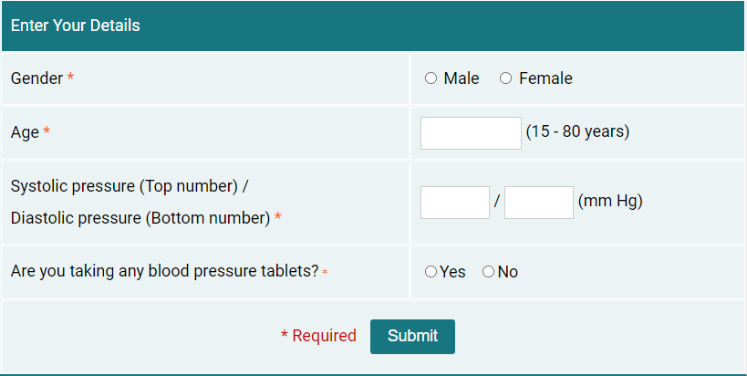

Figure 1.8.1: Blood Pressure Calculator website

**Advantages:**

It is easy for the site user to know if his blood pressure value is low, normal, high, or very high depending on the age of the user, and it displays different blood pressure values based on age and gives some advice to reduce blood pressure.

**Disadvantages:**

The website does not give a description of the patient's health condition; it only gives a description of the patient's blood pressure.

**Development:**

The website gives a description of the patient's health status in the form of a percentage based on the blood pressure value, in addition to other values such as diabetes, etc., which the user enters.

**2. Symptomate**

<https://symptomate.com/ar/interview/5?fbclid=IwAR3URjTkkPKRDN0NLQtpJawlvCrywbUly0jkgqyF9CZ9_iDxoNJMWwV0AEs>

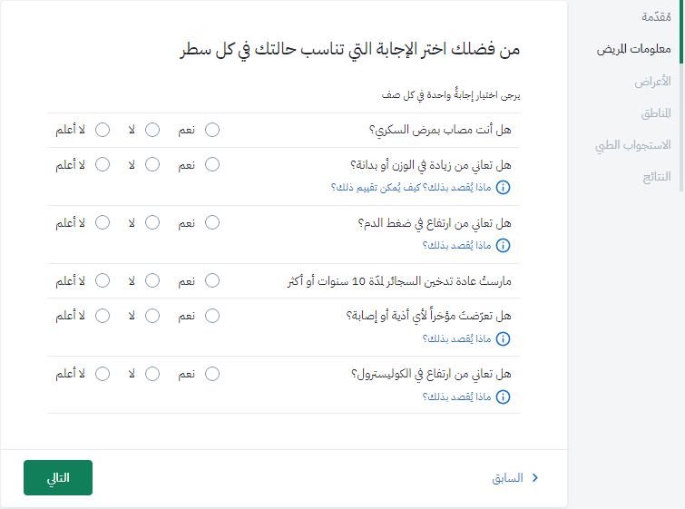

Figure 1.8.2: Symptomate website

**Advantages:**

• The Symptomate website has a user-friendly interface that is easy to navigate and use. Users can easily input their symptoms and receive a list of possible conditions.

• The website is accessible to anyone with an internet connection, making it convenient for people to get a quick medical consultation from their homes.

• Symptomate It analyzes users' symptoms and provide a list of possible conditions. This makes the diagnosis process faster.

**Disadvantages:**

• The Symptomate can only provide a list of possible conditions based on users' symptoms, and it is not a substitute for a professional medical diagnosis. Users may misinterpret their symptoms or omit important information, leading to inaccurate results.

• The Symptomate does not take into account a user's medical history or other personal factors that may affect their diagnosis. This lack of personalization may lead to inaccurate or irrelevant results.

**Development:**

It is possible to take advantage of the technique of introducing symptoms and developing it to allow the introduction of any traces or previous examinations related to the disease that a specific doctor or hospital had obtained and used to present an assessment of the general health status of the disease with some advice on the need to consult a doctor.

**3. Blood pressure test**

<https://www.nhs.uk/conditions/blood-pressure-test/?fbclid=IwAR3v6YpBvhfDRjsVUCL5iRBViJveZBIpXrbE_mPDpbc6m7Arm5pW-mG2jj0>

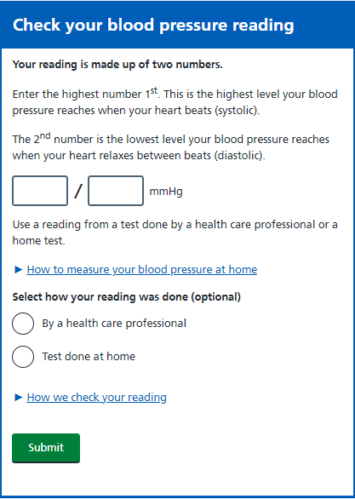

Figure 1.8.3: Blood Pressure test website

**Advantages:**

The website provides health recommendations for the patient after calculating the infection rate and shows the result of the examination with a chart to better illustrate the result of the examination

**Disadvantages:**

The app does not ask users about their weight or age which are important factors and other chronic diseases related to blood pressure.

**Development:**

Putting age and weight among the influencing factors and asking the user about them, as in expert systems.

**4. Beat Diabetes Calculator**

<http://www.beat-diabetes-calculator.com/>

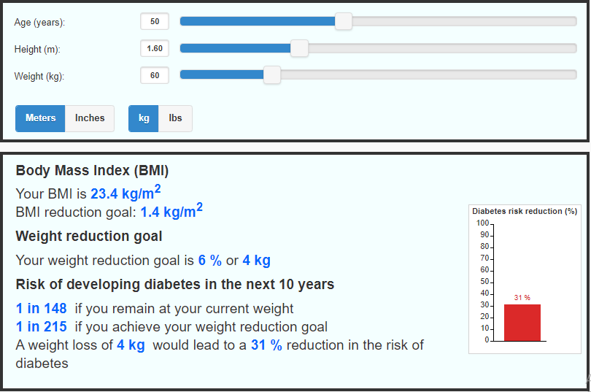

Figure 1.8.4: Beat Diabetes Calculator website

**Advantages:**

* The Beat Diabetes Calculator website allows users to calculate their risk of developing diabetes from their own homes, without the need to visit a healthcare provider.
* The website is accessible to anyone with an internet connection, making it a useful tool for individuals who may not have easy access to healthcare facilities.
* The site is designed to be free and easy to use, making it accessible to everyone
* The website does not require users to provide personal information, ensuring privacy and confidentiality.

**Disadvantages:**

* The website checks whether you have an increased risk of diabetes due to your weight, and there is no possibility to enter any additional information and does not take into account all possible risk factors for diabetes, which may result in inaccurate results.
* The website does not provide health recommendations for the patient after calculating the infection rate
* The website may not be accessible to individuals who do not speak English, as it is only available in English.

**Development:**

Developing the Website to allow the entry of additional information, such as previous examinations, in order to diagnose the condition based on a set of information and readings, and to produce more accurate results.

Providing the patient with a set of recommendations and medical advice appropriate to their condition based on the results of the examination.

# **1.9 Advantages:**

* The ease of use of the site makes it more convenient than making an appointment with a doctor or going to the hospital. This can be especially useful for individuals with busy schedules or those who live in remote areas to Saves time.
* The system is completely free, making it an affordable option for individuals who cannot afford regular medical check-ups or consultations.

**Chapter 2**

**System requirements analysis & Methodology**

**2.1 Introduction:**

The stage of collecting requirements and analyzing them is one of the basic stages in order to build the system in a correctly.

In this chapter, we will present a complete description of the functional and non-functional requirements of the system to be operated. This chapter includes functional system requirements, description of system functional requirements, verification criteria, data description, and description of the system interface.

* **System requirements**.
* Functional requirements.
* Non-functional requirements.

# 

# **2.2 Functional Requirement’s:**

For

* System
* Users
  + Admin
  + User

**2.2.1 Functional of System:**

* **Operations management:**
* Analyze the data entered by the user.
* Show the test result to the user.
* Recommendations based on their assessment results.
* Provide the user's previous tests.

**2.2.2 Functional of Users:**

* **Admin:**
* **Access:**
* Login to the home page and Dashboard.
* **Operations management:**
  + Managing users (add, update, read and delete).
  + Add new admin
* **User:**
* **Access:**
* Sign Up.
* Login.
* **Operations management:**
* Do a new test by entering (low and high pressure, gender, weight, age and height ...etc).
* View user’s history over time.
* Provide feedback if the user wants.

# **2.3 Non-Functional Requirement’s:**

* 1. **Work environment:**
* The system works in any environment (Windows, Linux, MAC...).
* It must be scalable and modified.
  1. **The performance:**
     + - Speed of access and review of different pages.
       - The speed of obtaining the service in order to log into the system.
     + Efficiency should be increased by accelerating data entry and transfer and rapid analysis of results.
  2. **Reliability:**
* This is through the processes through which users interact with the system, as these processes are programmed in a way that prevents errors from occurring, and deals with them if they occur.
* The system must perform its requirements with a high level of accuracy.
  1. **Safety:**
* Not allowing unauthorized persons to enter the system or the database and change it, through the use of a username and password.
  1. **Privacy:**
* To provide privacy for each of the members, as each member has a user name and an information for it, and no one else can use it.
  1. **Ease of use:**
* Ease of access to the system and ease of use.
* Easy to update the system.
* Easy data transfer.
  1. **Language Selection:**
* Users should be able to easily switch between Arabic and English languages.
* Provide a language selection option in the user interface, such as a dropdown menu or a language toggle button.

# **2.4 Methodology:**

we aim to make use of machine learning techniques to identify factors that effect on blood pressure diseases.

To ensure an efficient and effective development process, we have chosen to adopt the Agile methodology.

Agile is a project management framework that focuses on iterative and incremental development, collaboration, flexibility, and responsiveness to change, With Agile, we intend to break the project into smaller, manageable tasks and regularly evaluate and adapt the approach based on emerging feedback and insights.

This iterative nature of Agile will allow me to continually refine and improve the machine learning model, as well as incorporate new data sources and variables that contribute to BP disease.

Agile's focus on collaboration will also enable me to work closely with stakeholders, such as healthcare professionals and domain experts, to gather their insights and ensure model accuracy and relevance to real-world scenarios.

In general, by adopting the Agile methodology, we expect a more dynamic and efficient development process that will enhance the success of my graduation project. *7

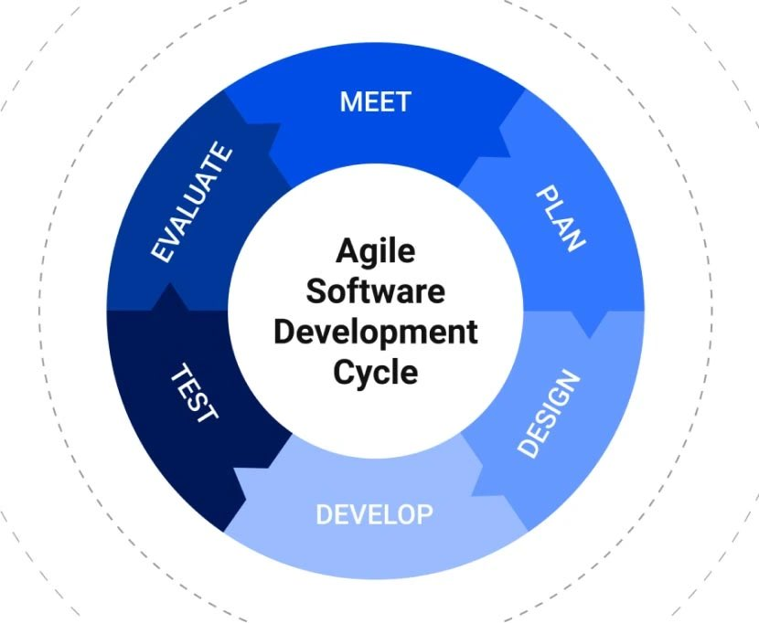

**Chapter 3**

**List of Diagrams:**

1. **Interaction Diagrams** These diagrams are a subset of behavior diagrams, emphasizing the flow of control and data among the things in the system being modeled.

* **Use Case Diagram:** Describes the functionality provided by a system in terms of actors, their goals represented as use cases, and any dependencies among those use cases.
* **Sequence Diagram**: Shows how objects communicate with each other in terms of a sequence of messages. Also indicates the lifespans of objects relative to those messages

1. **Behavior Diagrams** These diagrams emphasize what must happen in the system being modeled. Since they illustrate the behavior of a system, they are used extensively to describe the functionality of software systems.

* **Activity Diagram:** Describes the business and operational step-by-step workflows of components in a system. An activity diagram shows the overall flow of control

1. **Structural models:** These diagrams emphasize the things that must be present in the system being modeled. Since they represent the structure, they are used extensively in documenting the software architecture of software systems.

* **Class Diagram:** Describes the structure of a system by showing the system’s classes, their attributes, and the relationships among the classes.

1. **Context models:** Context models are used to illustrate the operational context of a system - they show what lies outside the system boundaries. Architectural models show the system and its relationship with other systems.

* **Architecture diagram:** Separates presentation and interaction from the system data. The system is structured into three logical components that interact with each other. The Model component manages the system data and associated operations on that data. The View component defines and manages how the data is presented to the user. The Controller component manages user interaction and passes these interactions to the View and the Model.

3.1: Use Case Diagrams:

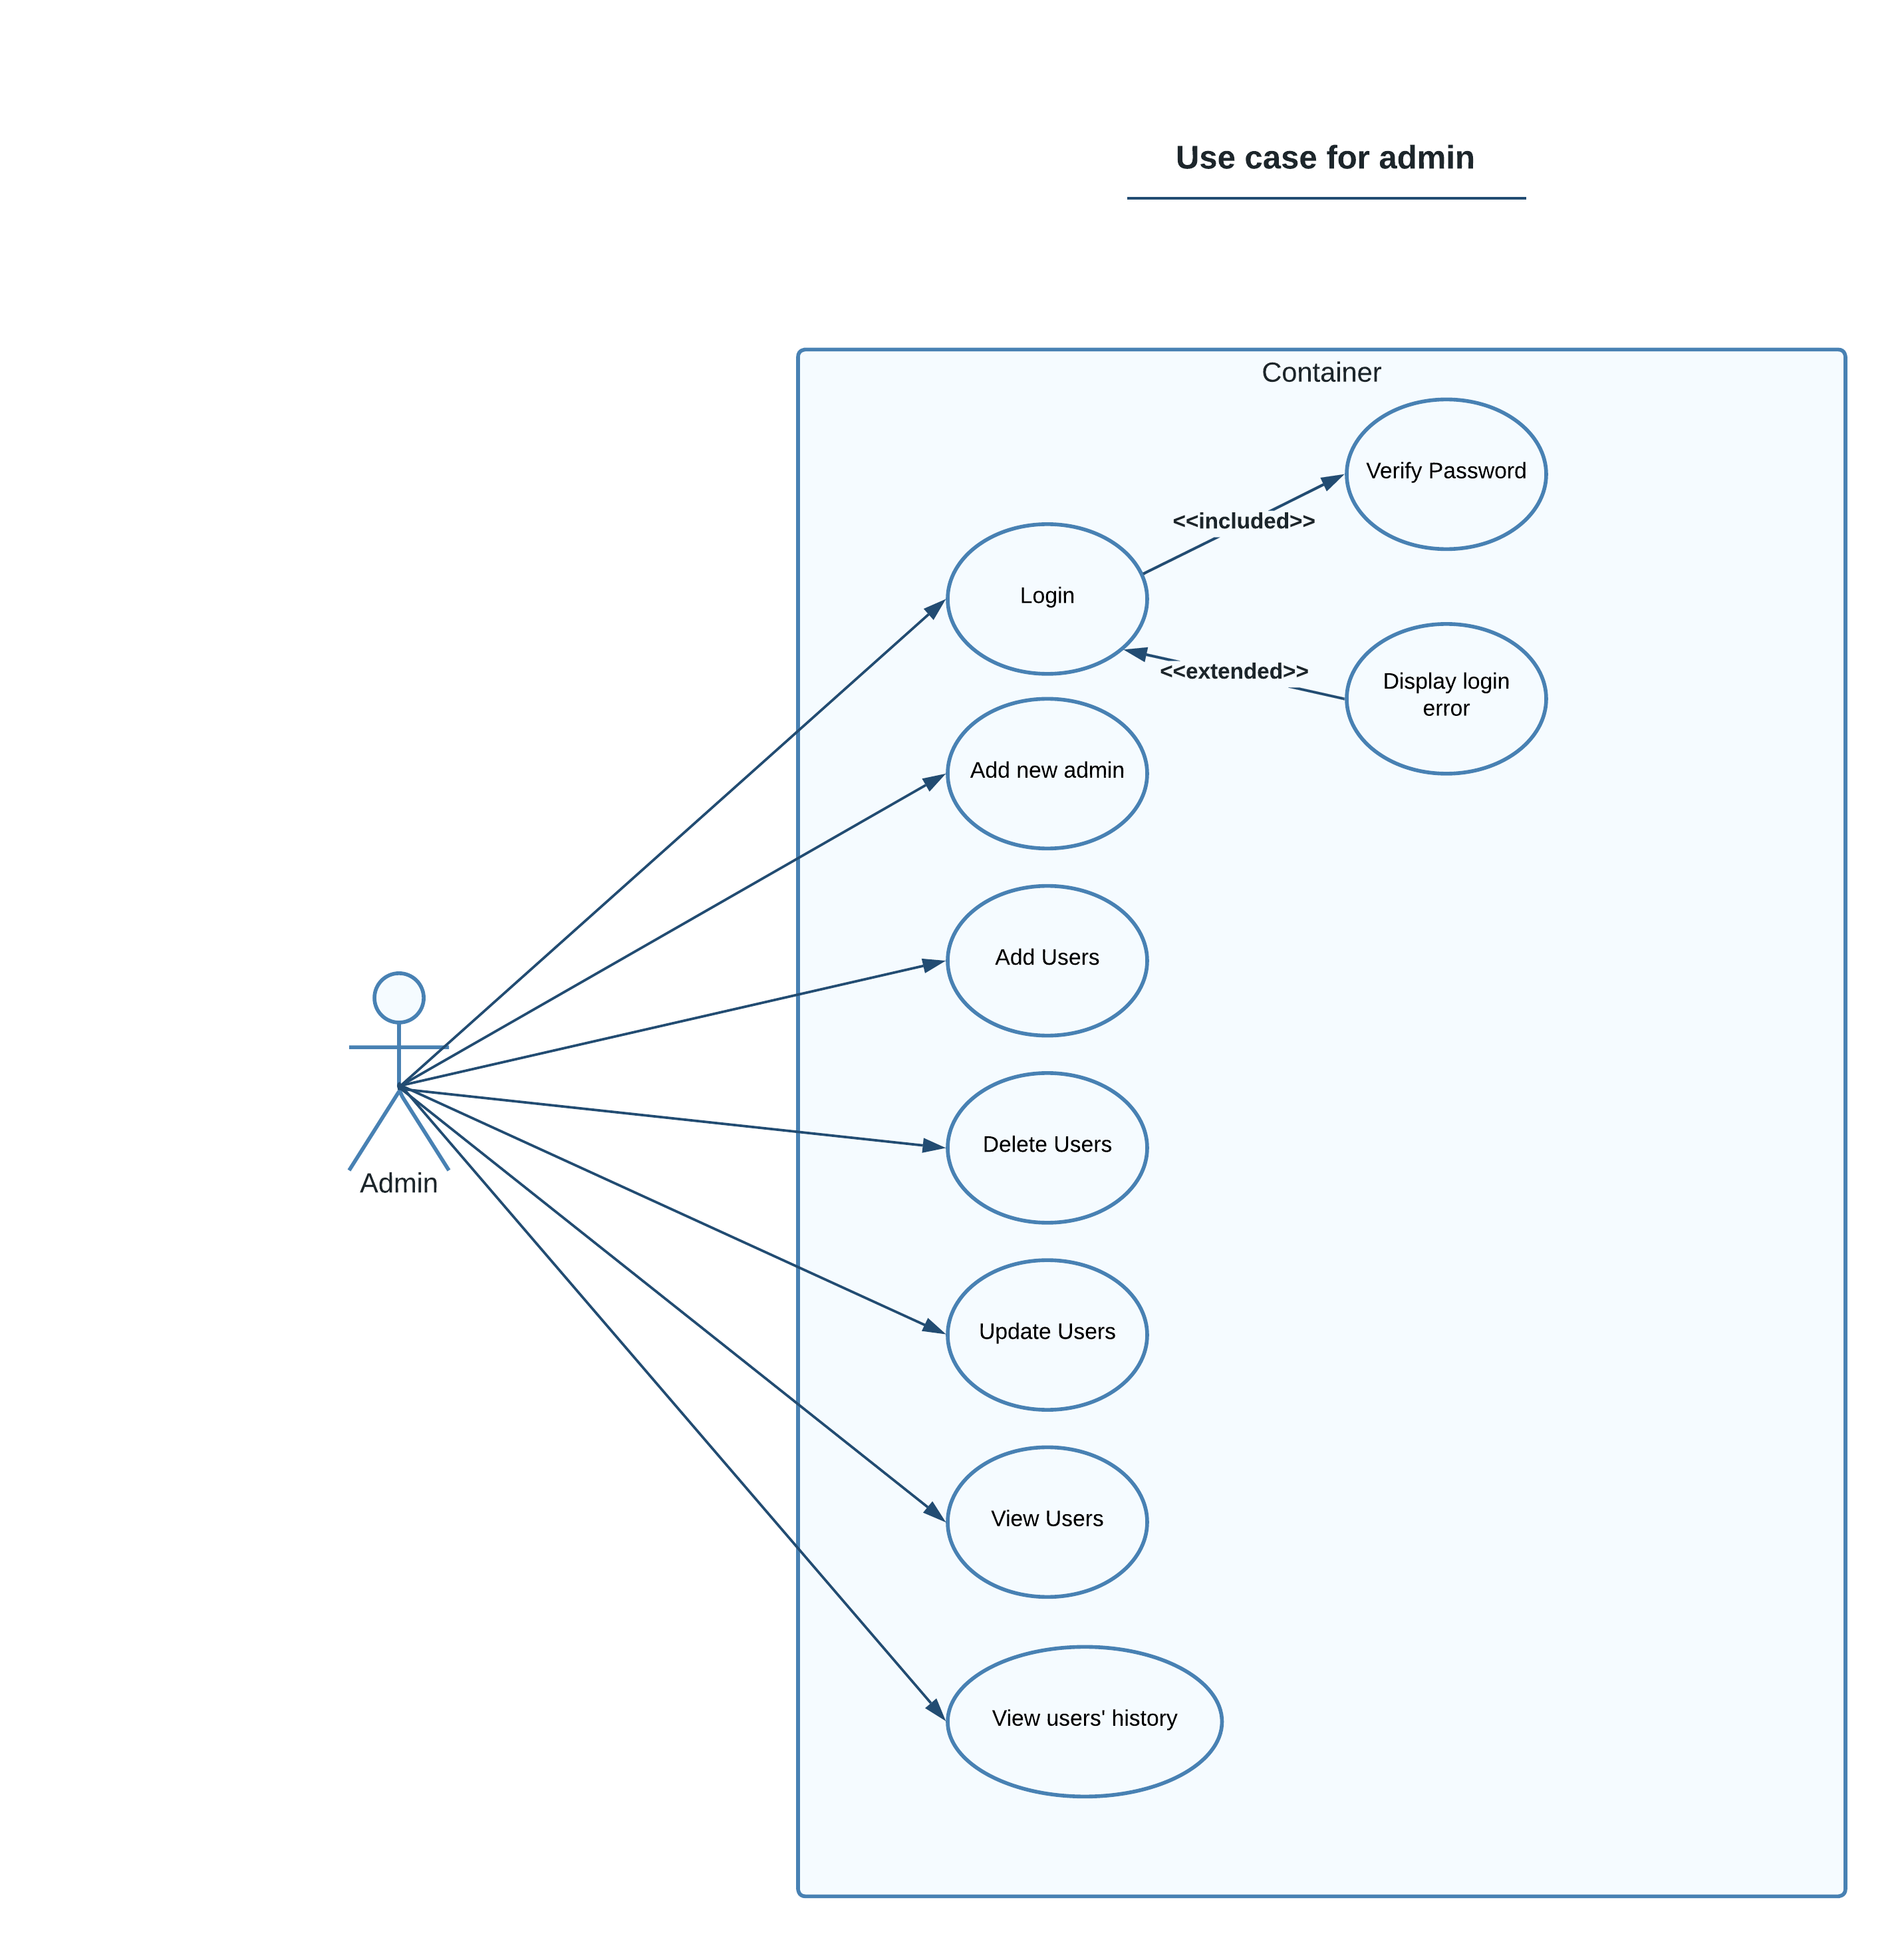

Figure 3.1.1: Admin use case diagram

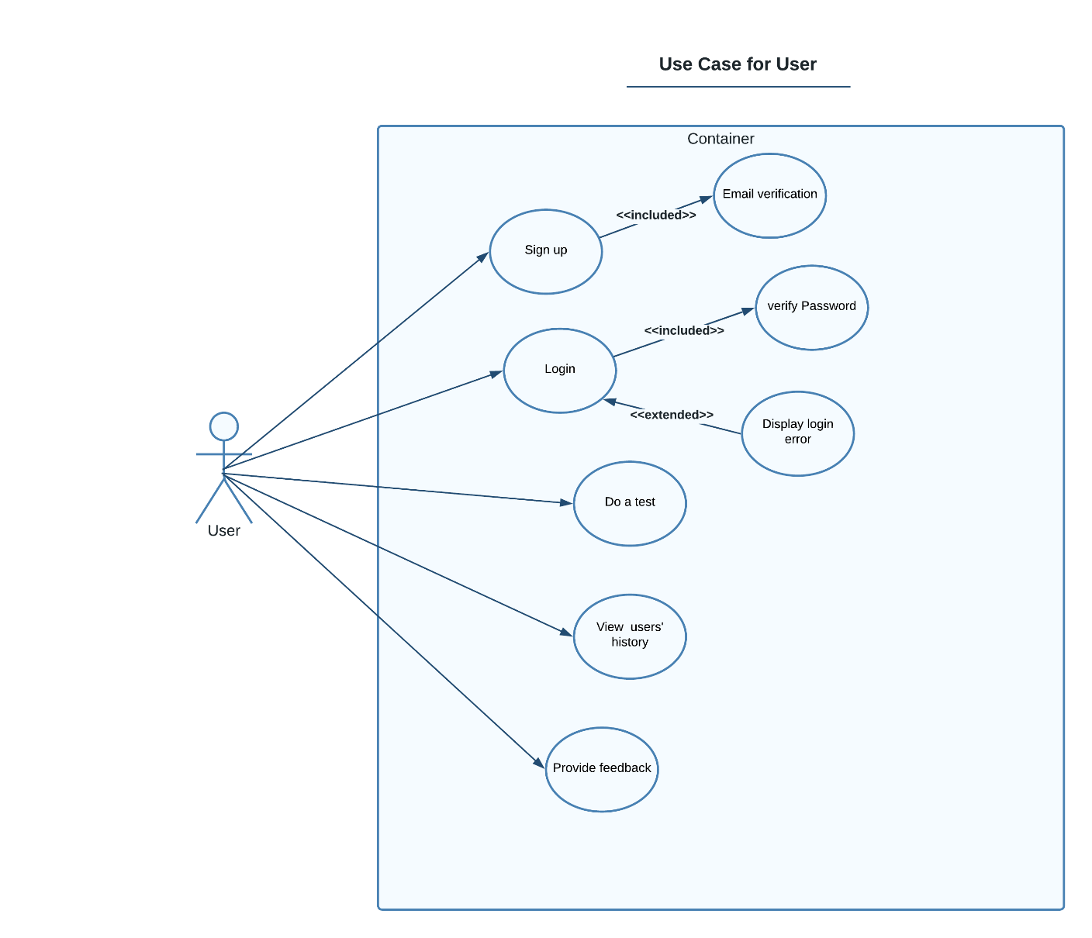

Figure 3.1.2: User use case diagram

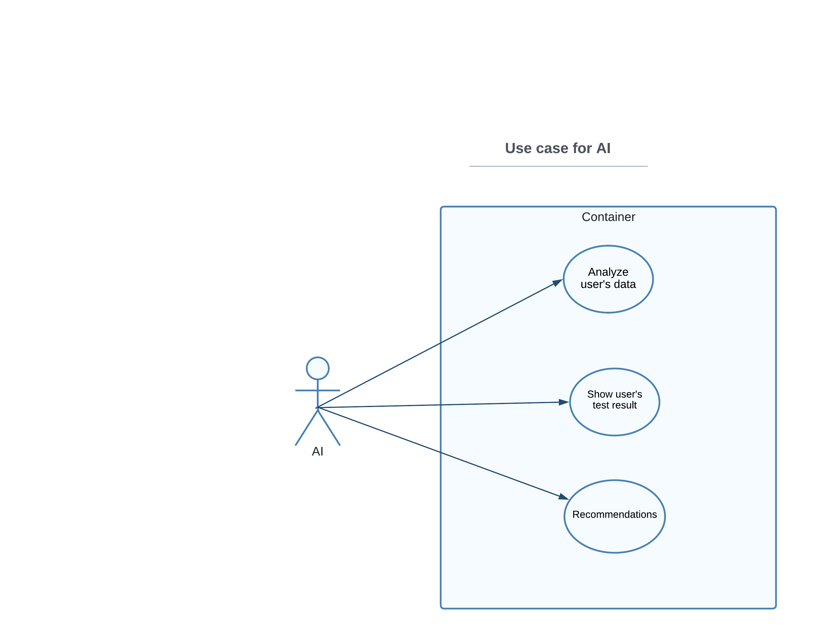

Figure 3.1.3: AI use case diagram

3.2: Use Case Description Diagrams:

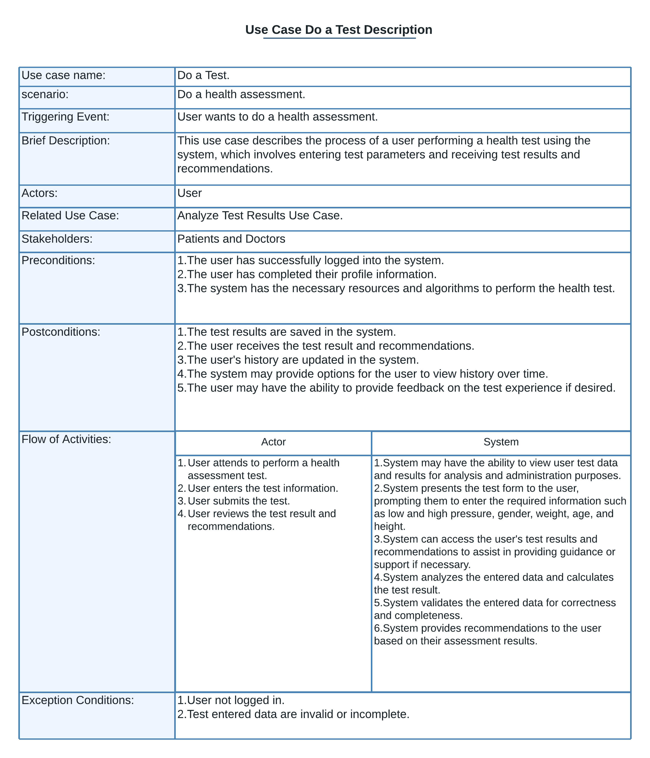

Figure 3.2.1: Do a Test use case Description diagram

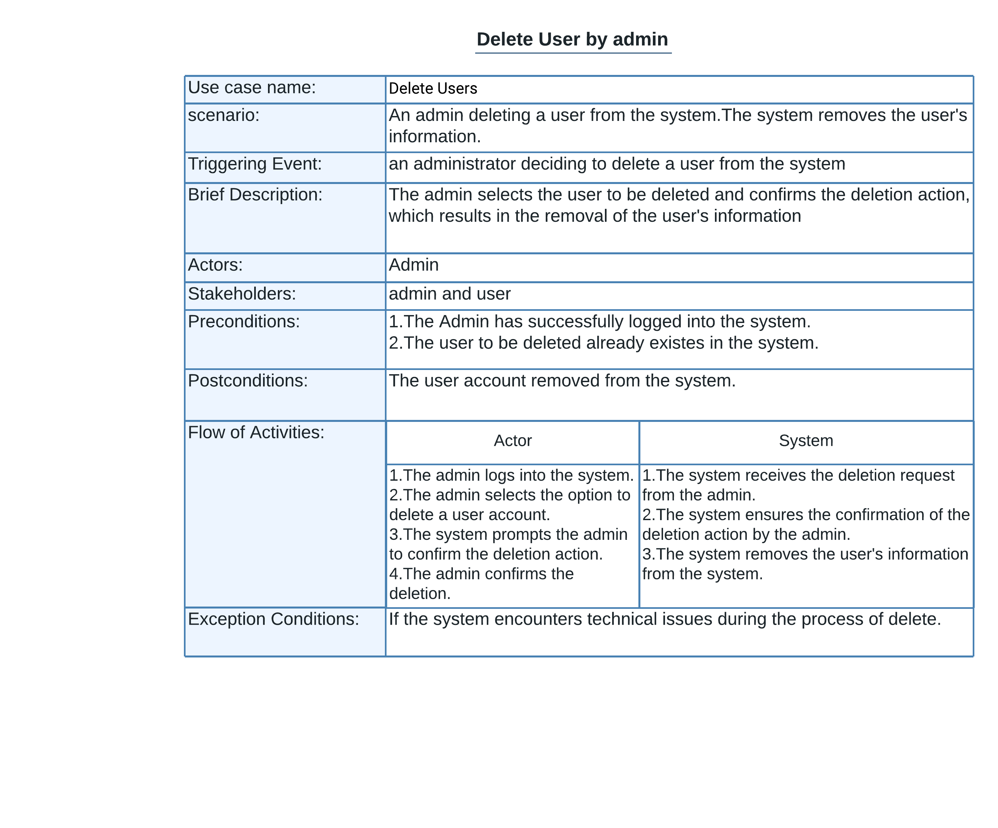

Figure 3.2.2: Delete user by admin use case Description diagram

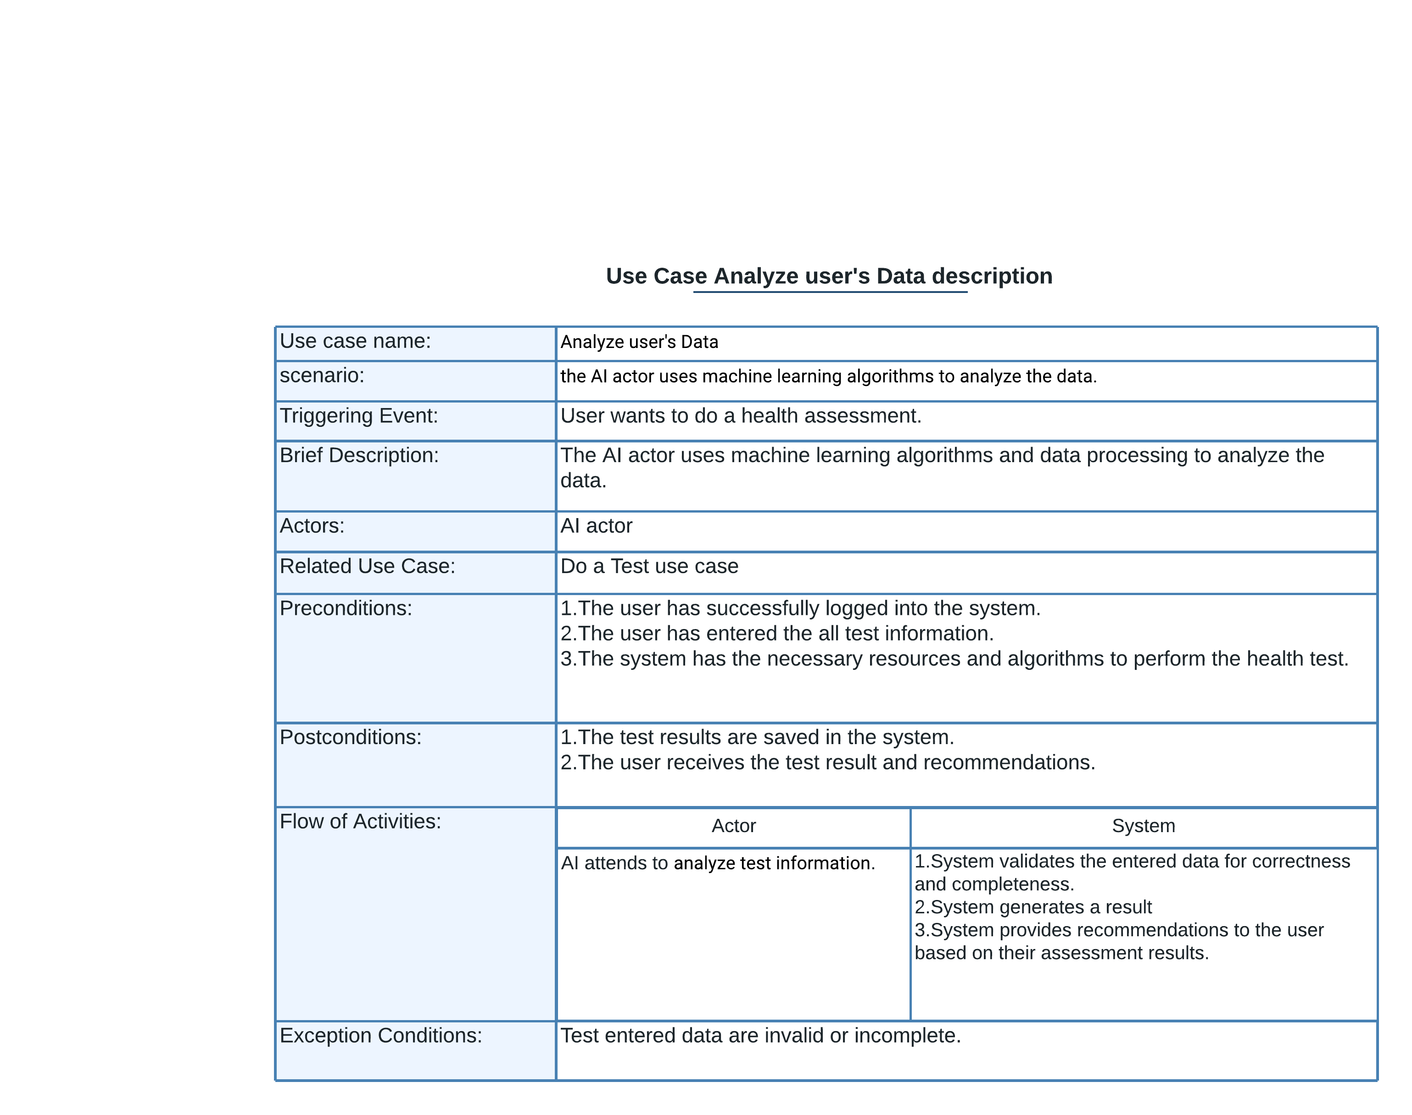

Figure 3.2.3: Analyze User’s Data use case Description diagram

3.3 Sequence Diagram:

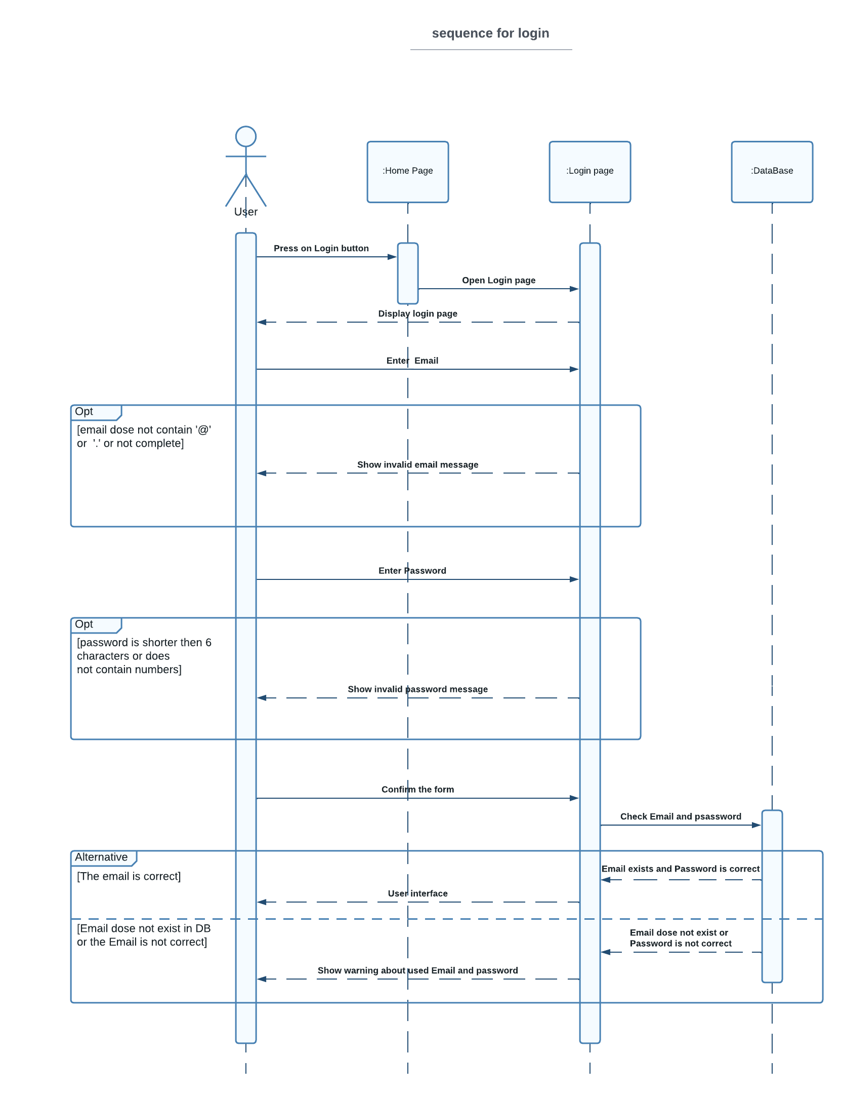

Figure 3.3.1: Login Sequence Diagram

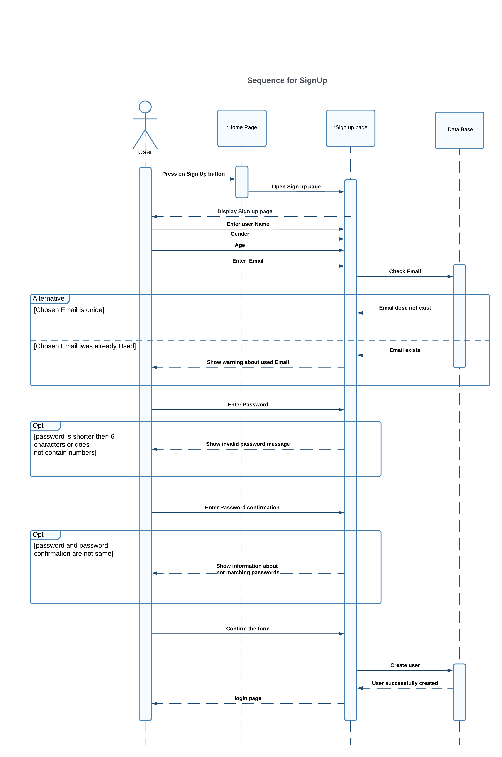

Figure 3.3.2: Signup Sequence Diagram

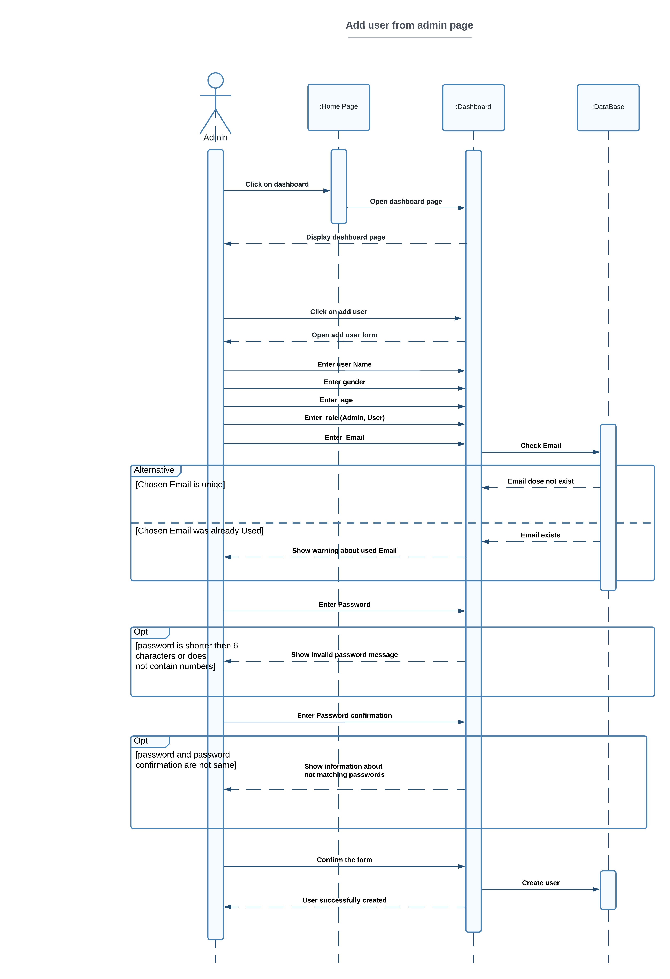

Figure 3.3.3: add user by admin Sequence Diagram

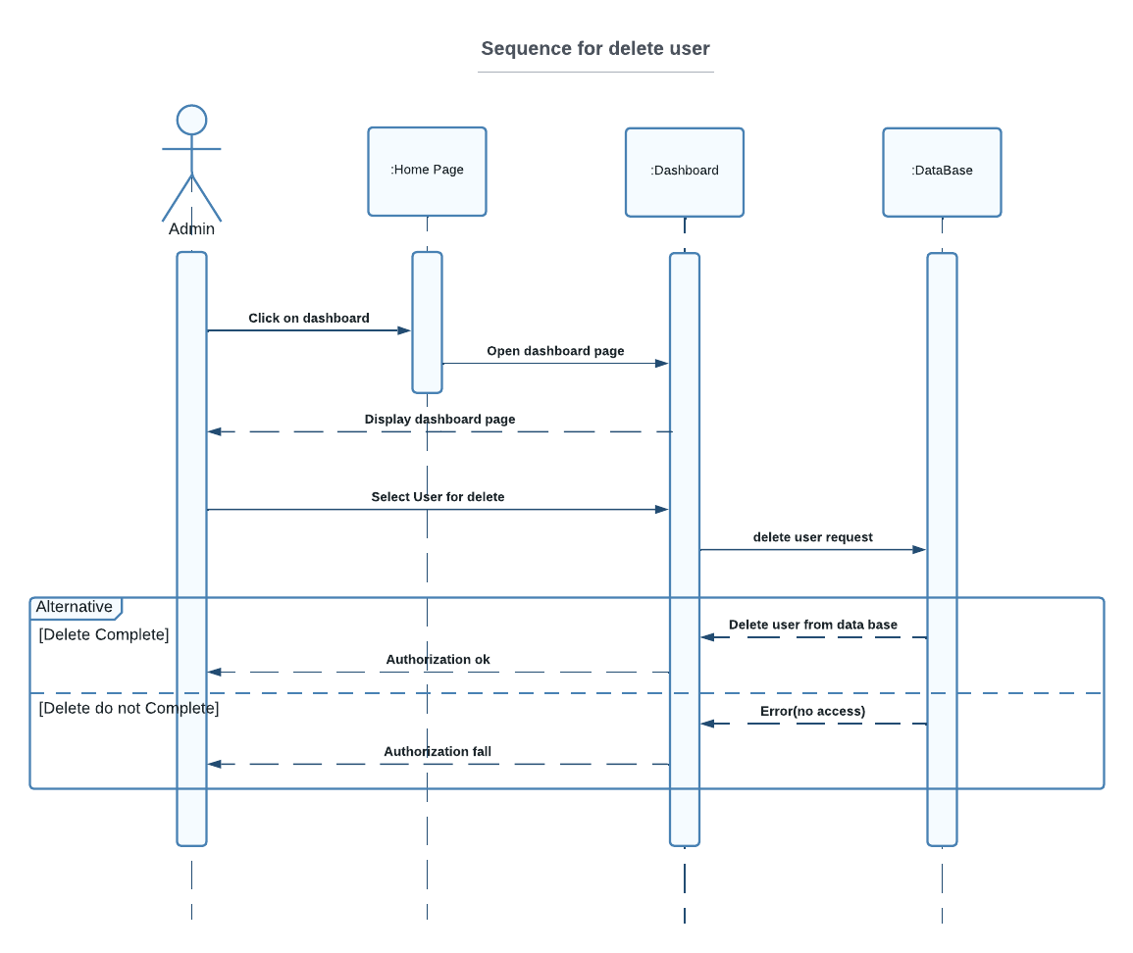

Figure 3.3.4: Delete user by admin Sequence Diagram

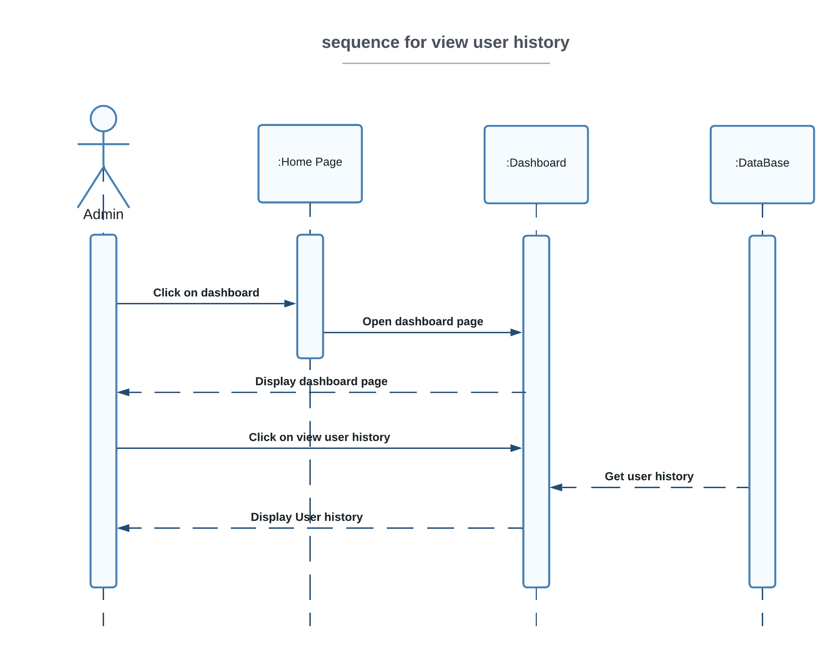

Figure 3.3.5: View user history by admin Sequence Diagram

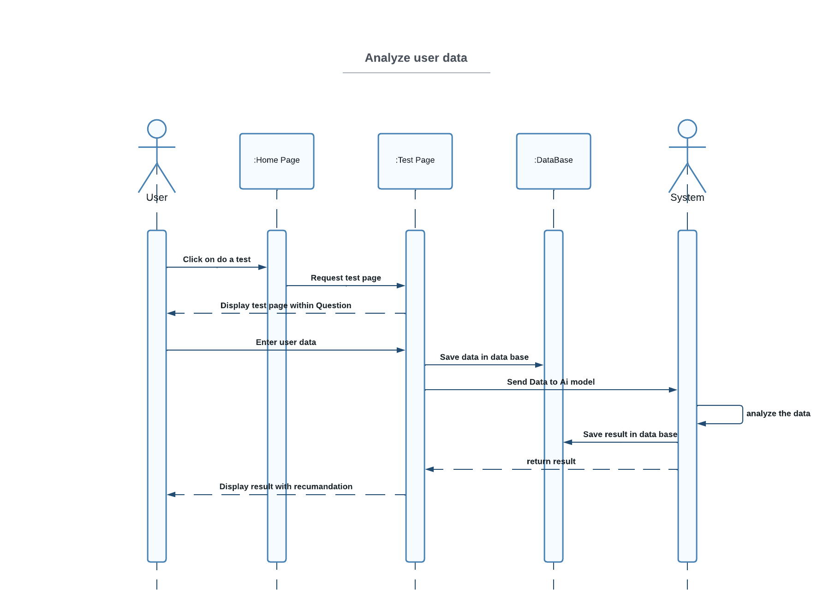

Figure 3.3.7: Analyzes user data Sequence Diagram

# 3.4 MongoDB Schema:

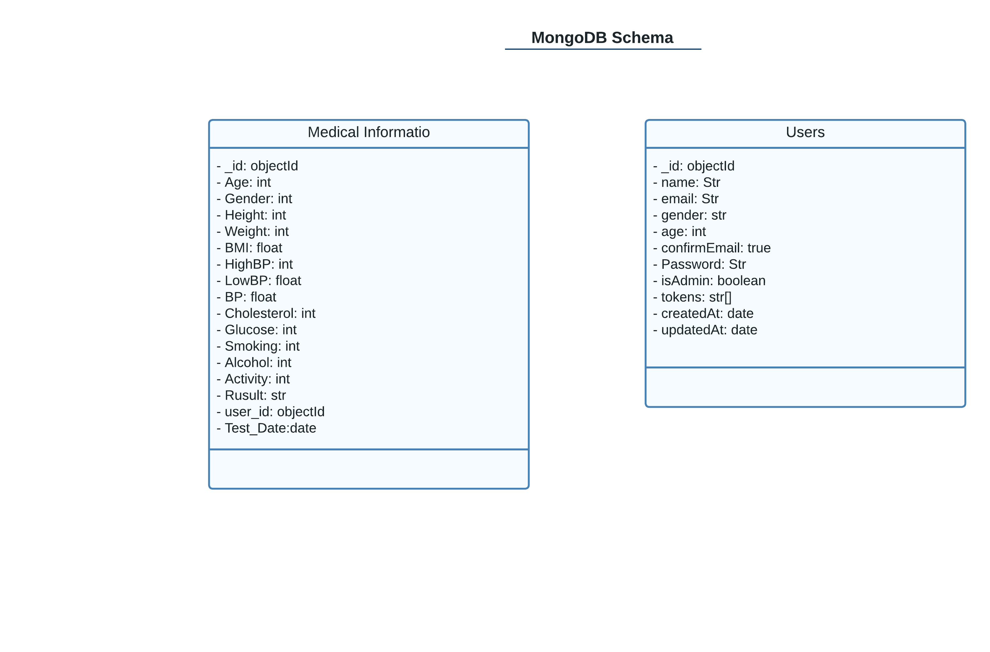

Figure 3.4: Class Diagram

# 3.5: Activity Diagram:

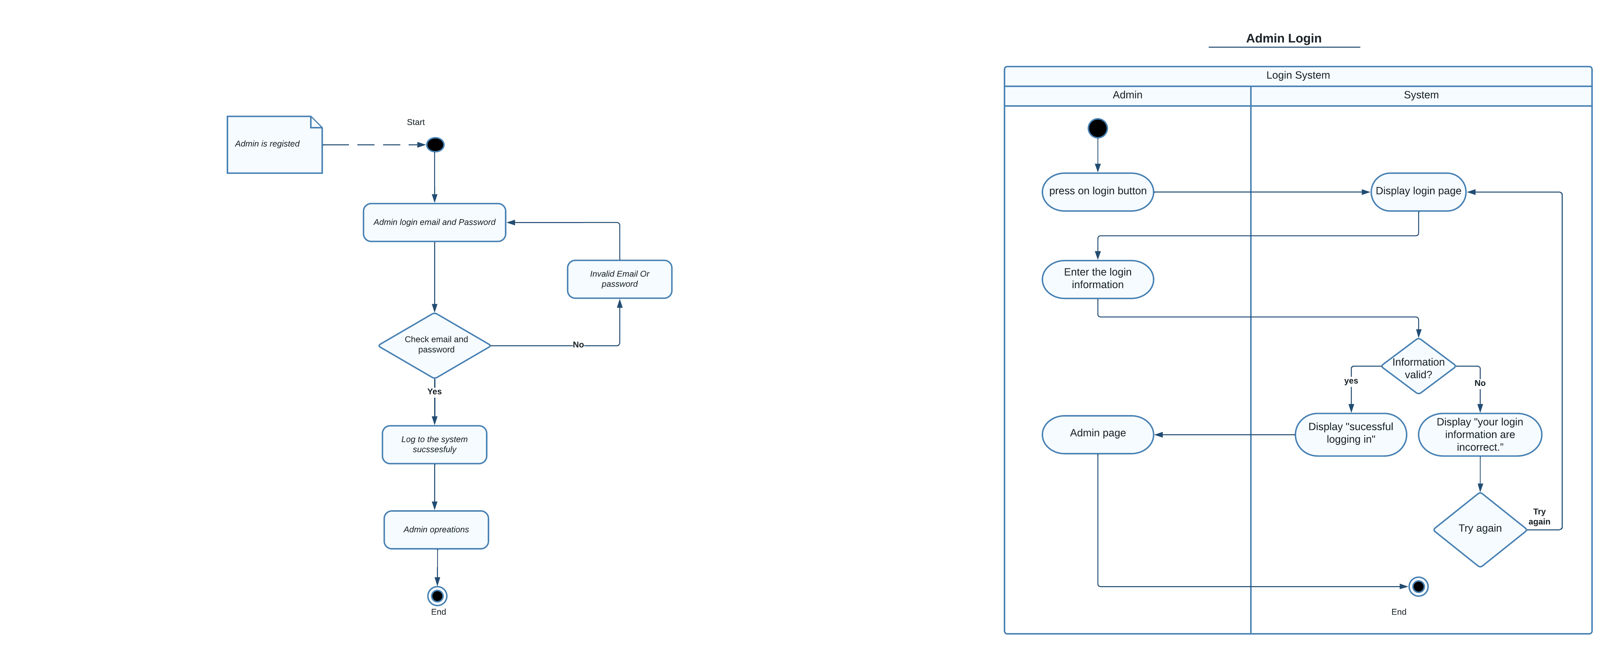

Figure 3.5.1: Admin Login Activity Diagram

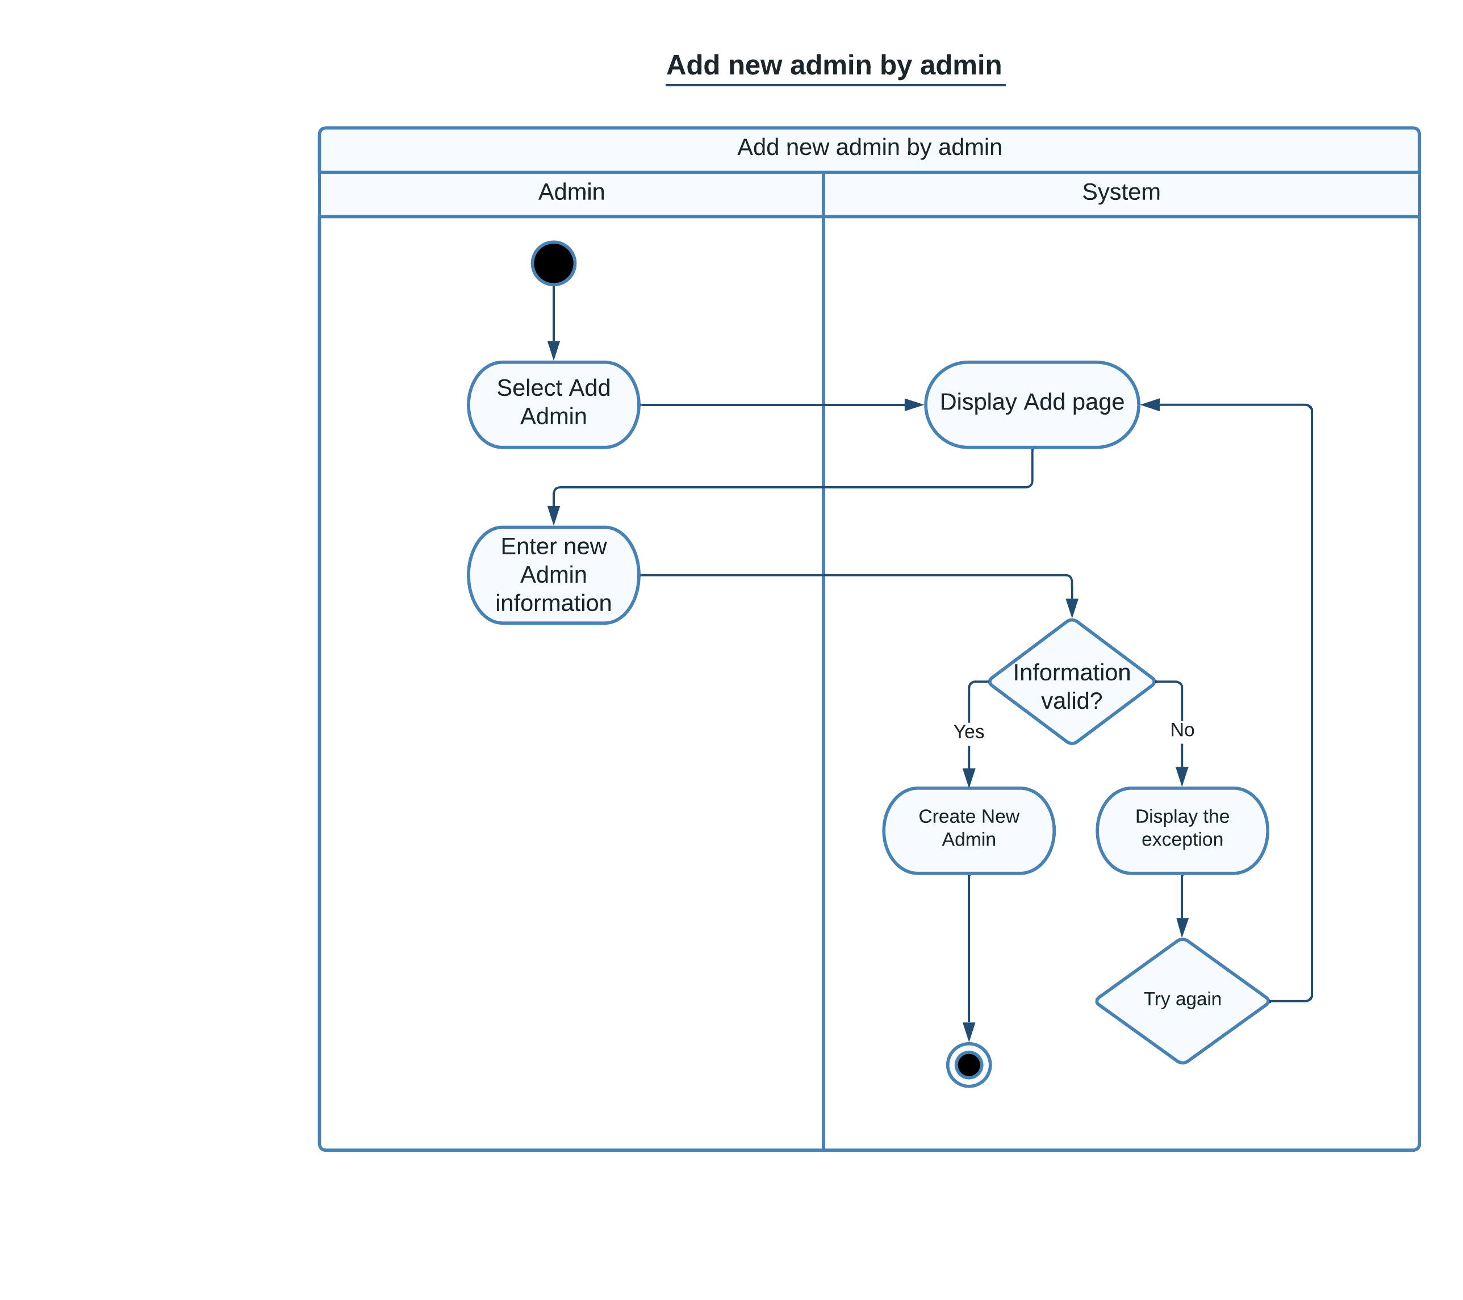

Figure 3.5.2: Add new admin by admin Activity Diagram

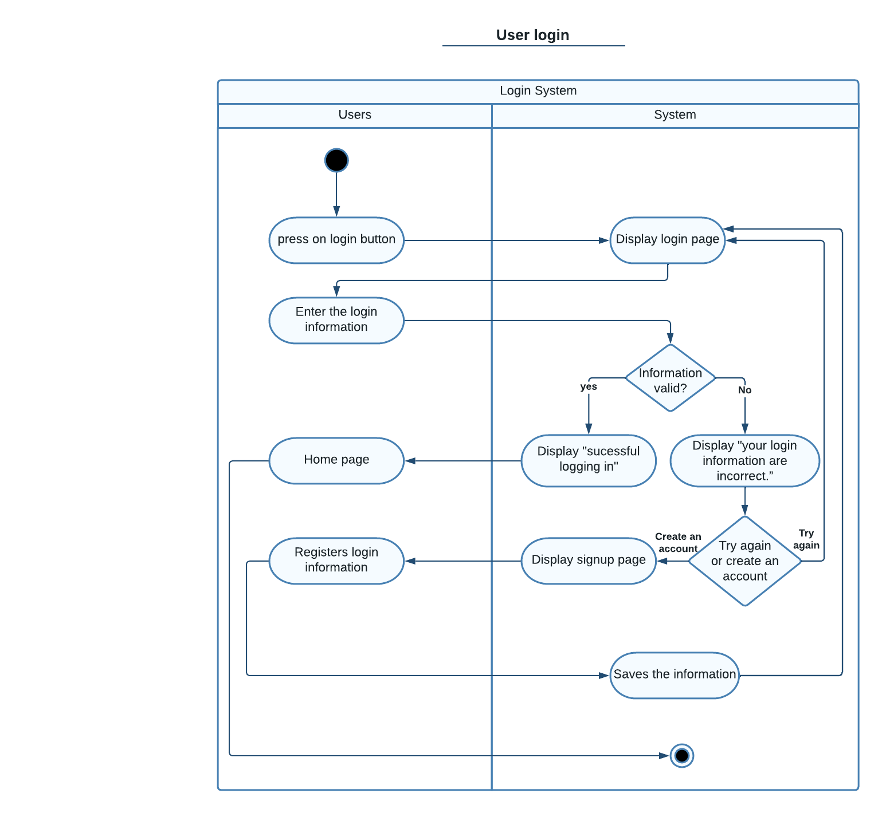

Figure 3.5.3: User Login Activity Diagram

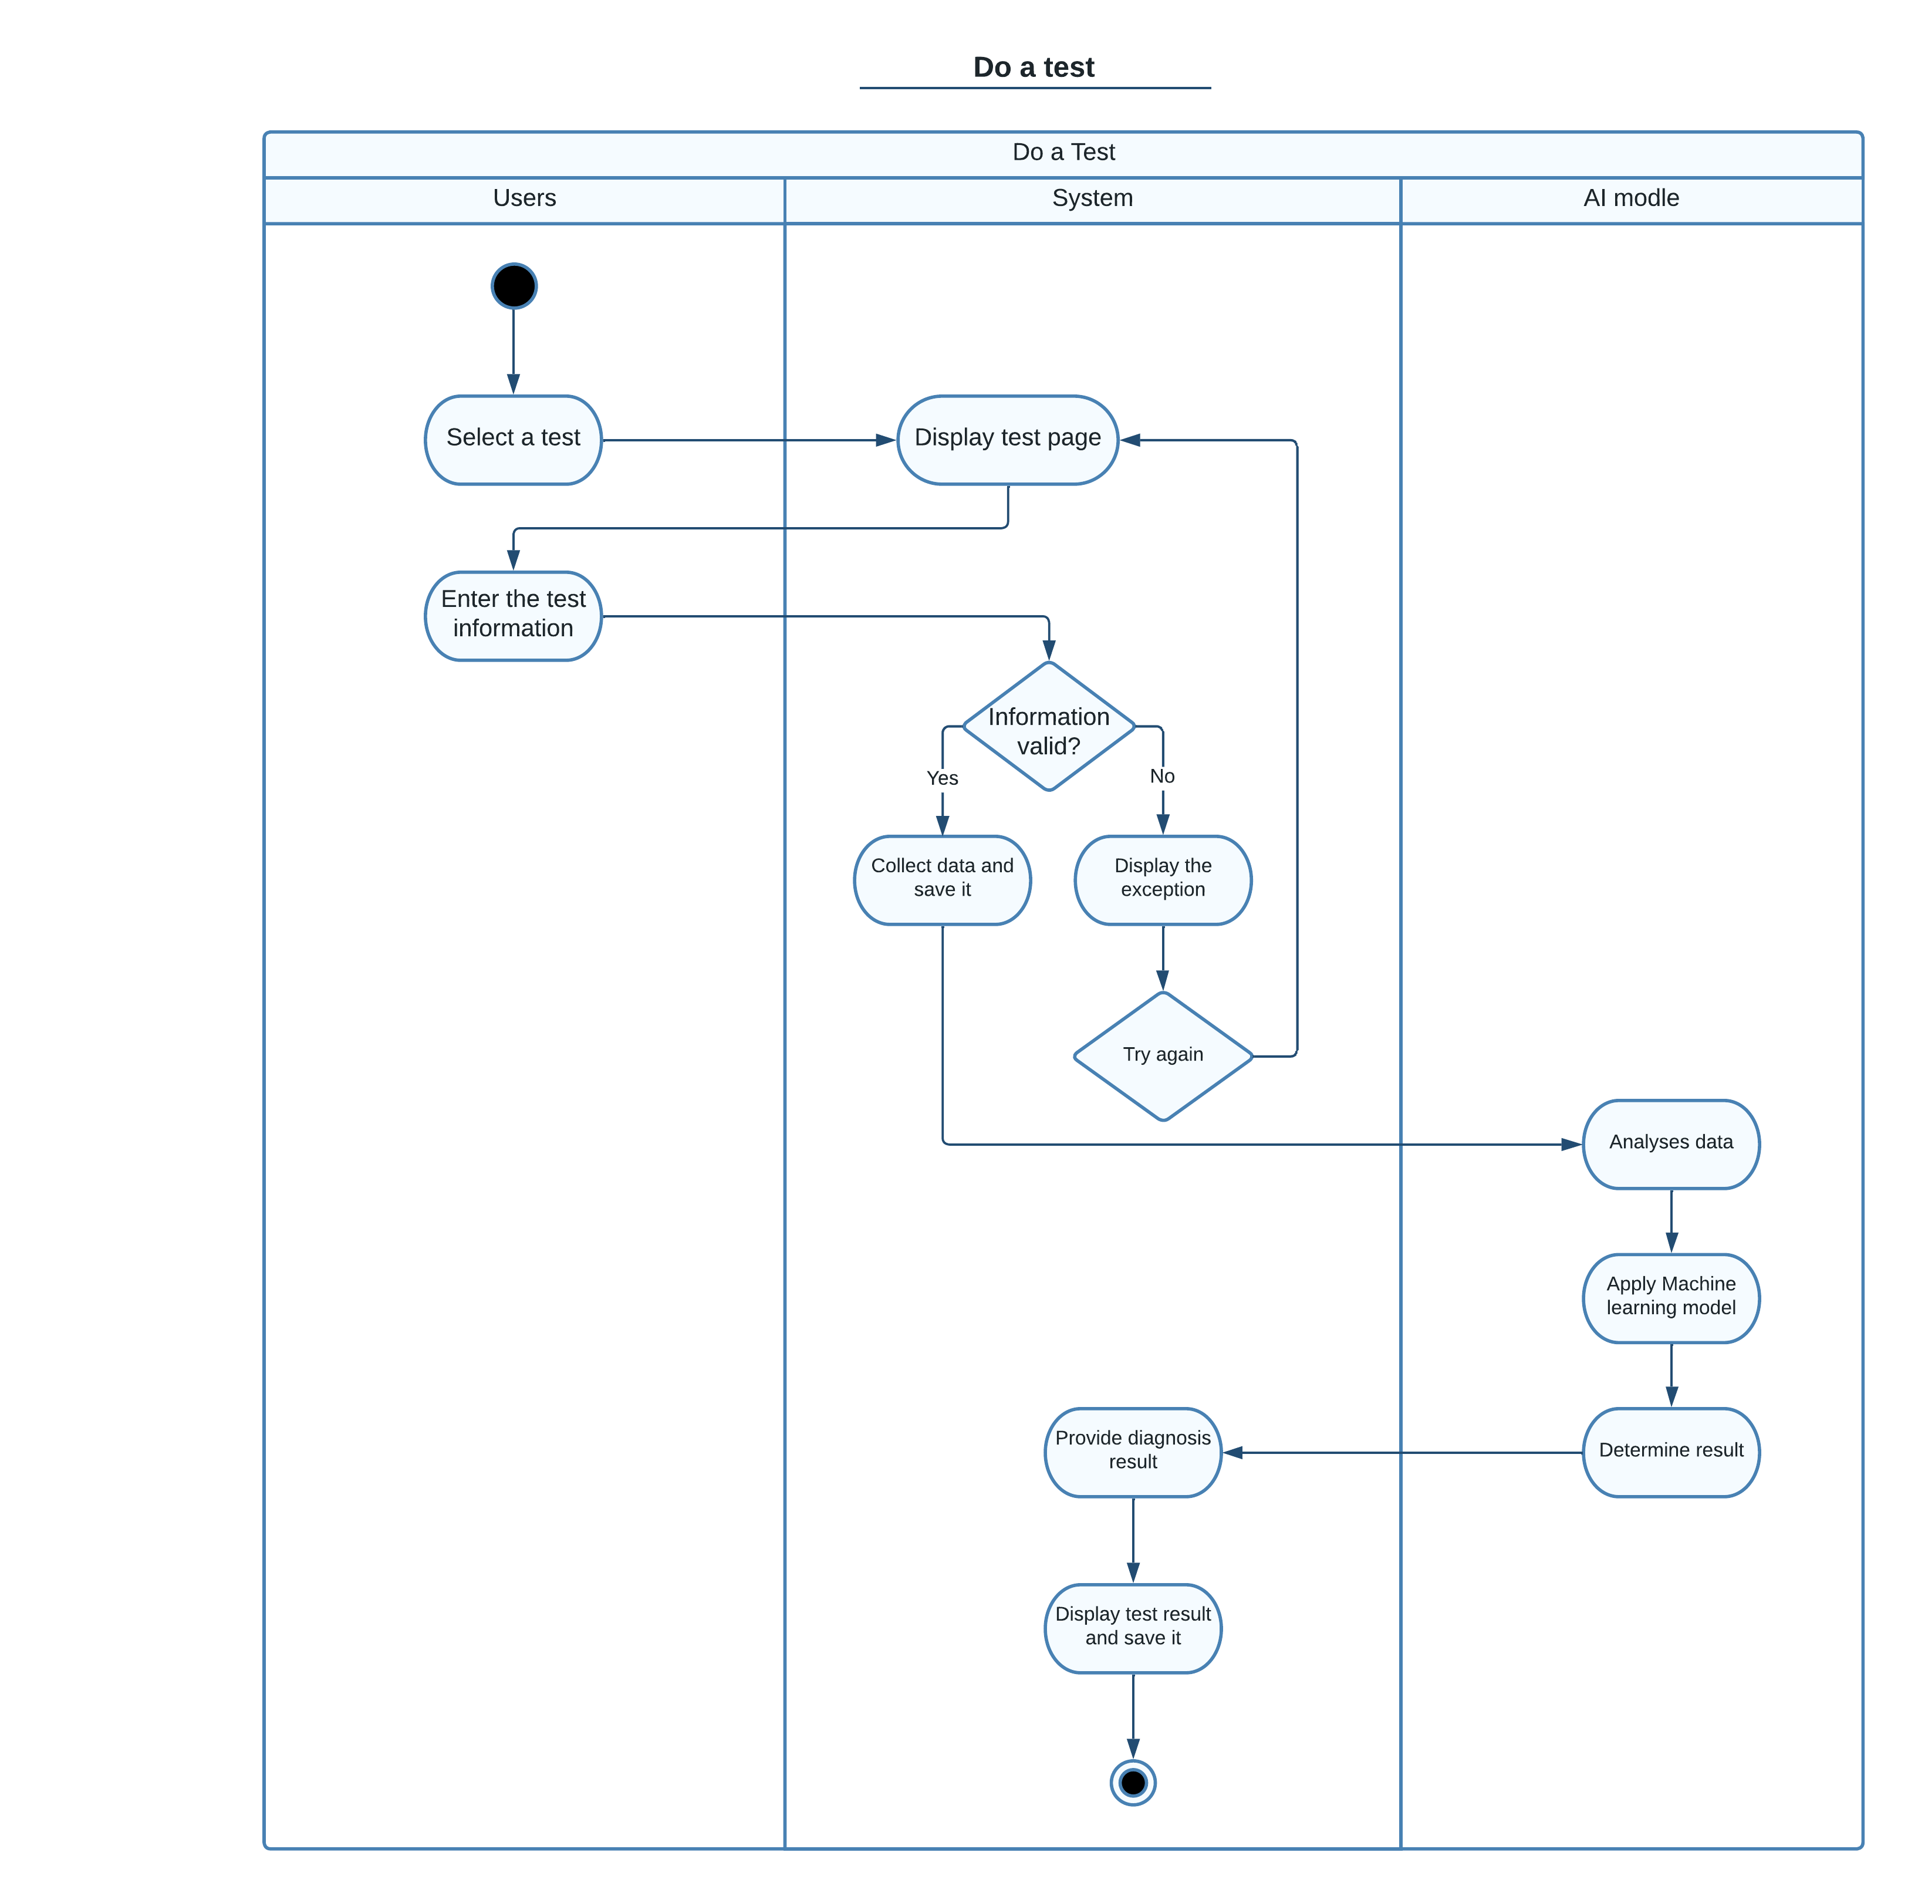

Figure 3.5.4: Do a test Activity Diagram

# 3.6: Architecture diagram (MVC):

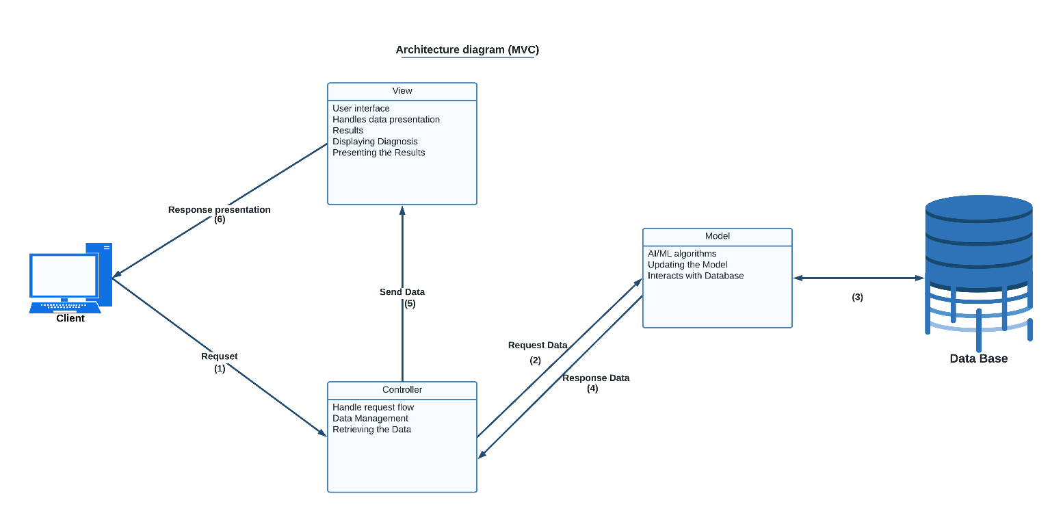

Figure 3.6: Architecture diagram (MVC)

# 3.7: UI:

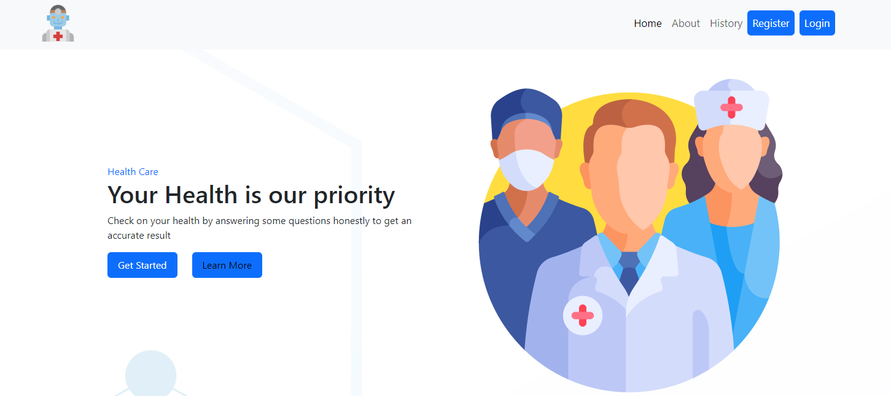

Figure 3.7.1: Home page UI

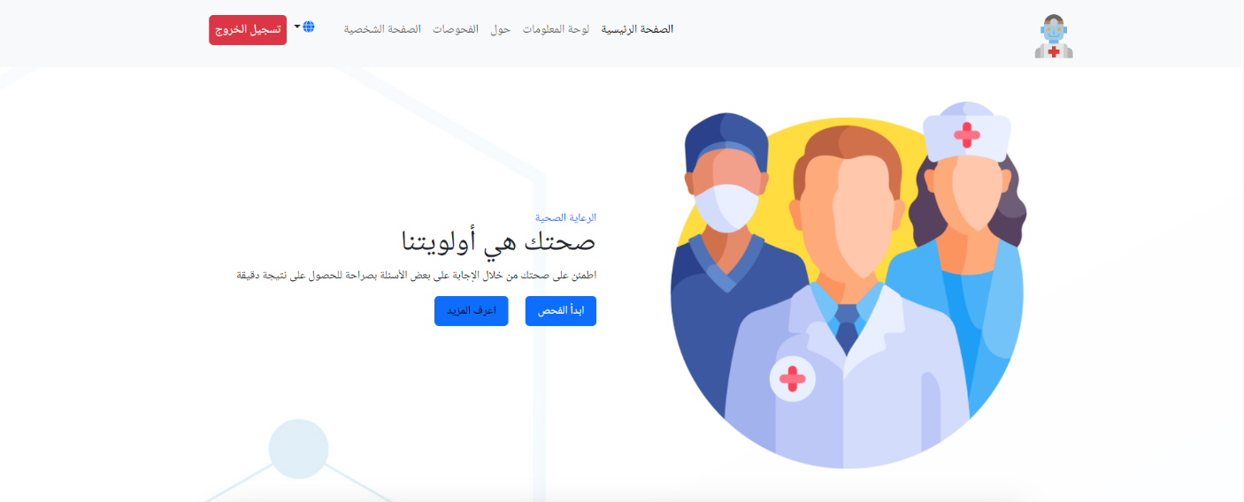

Figure 3.7.2: Home page UI in Arabic

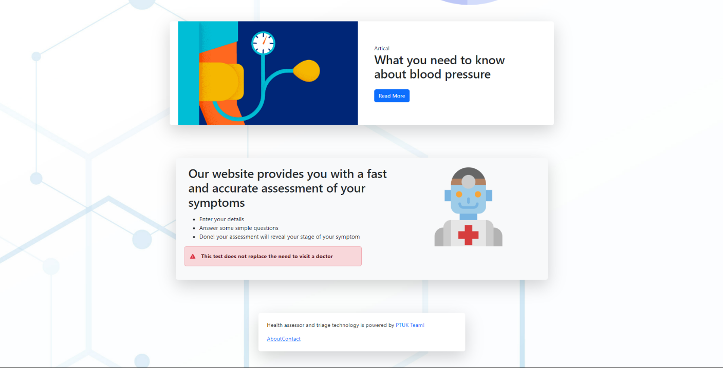

Figure 3.7.3: Home page UI

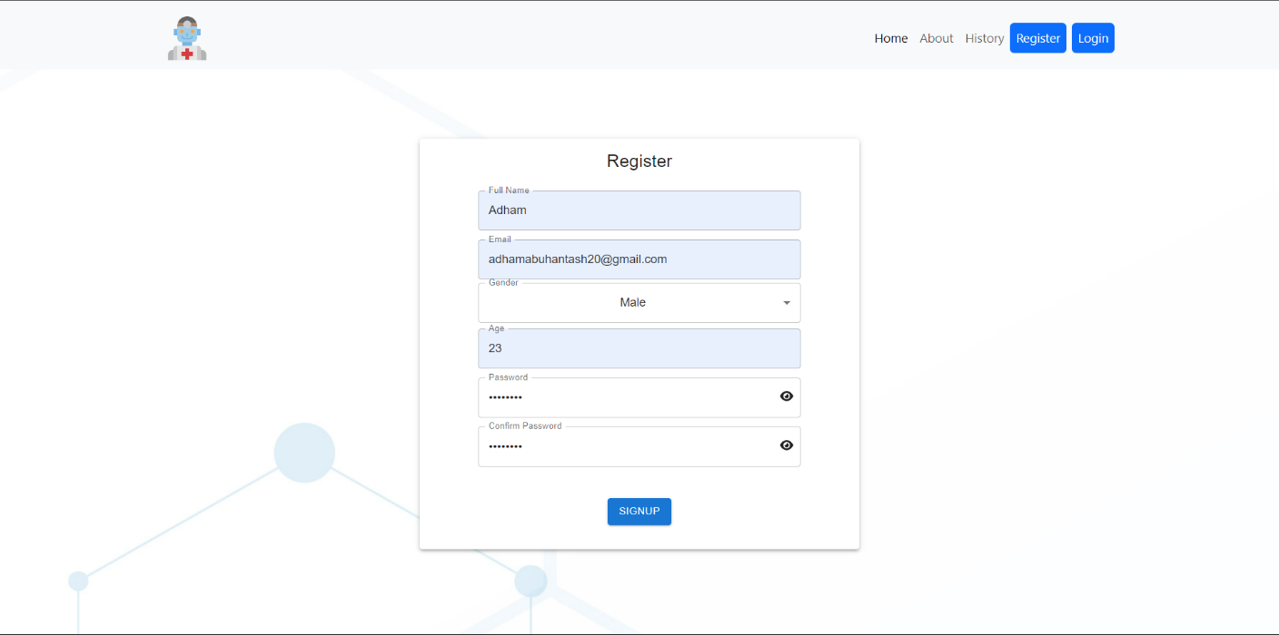

Figure 3.7.4: Signup page UI

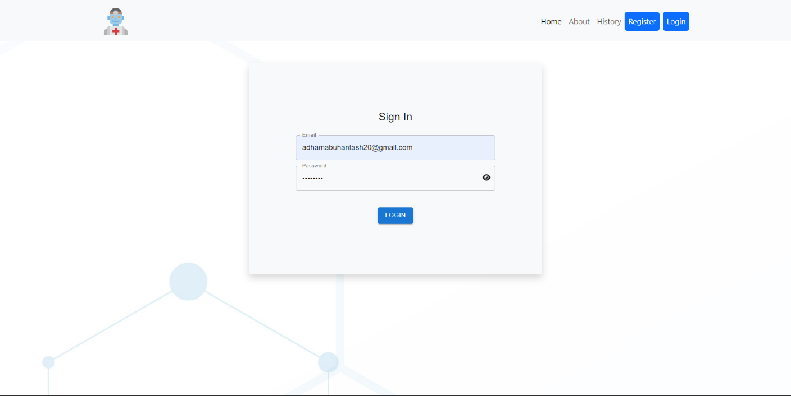

Figure 3.7.5: Sign in page UI

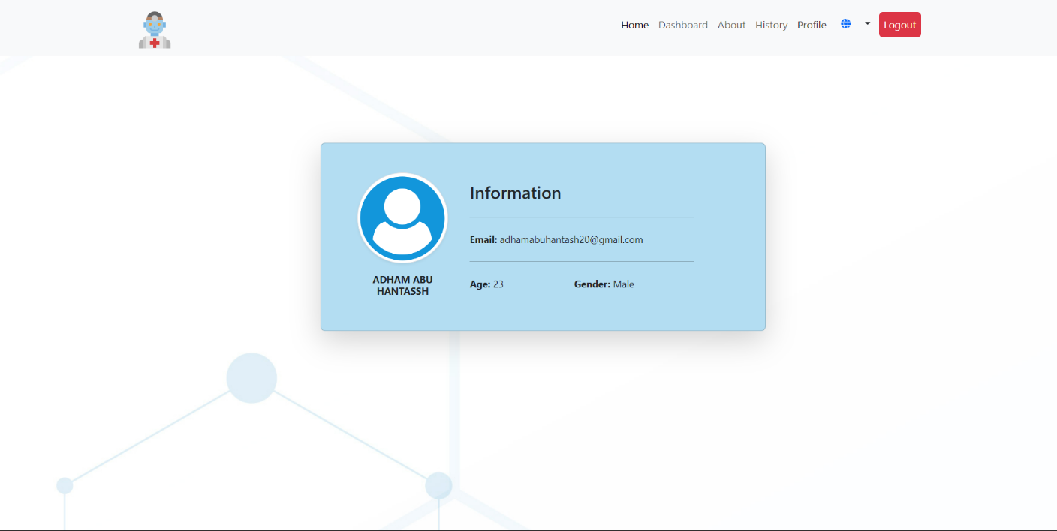

Figure 3.7.6: Profile UI

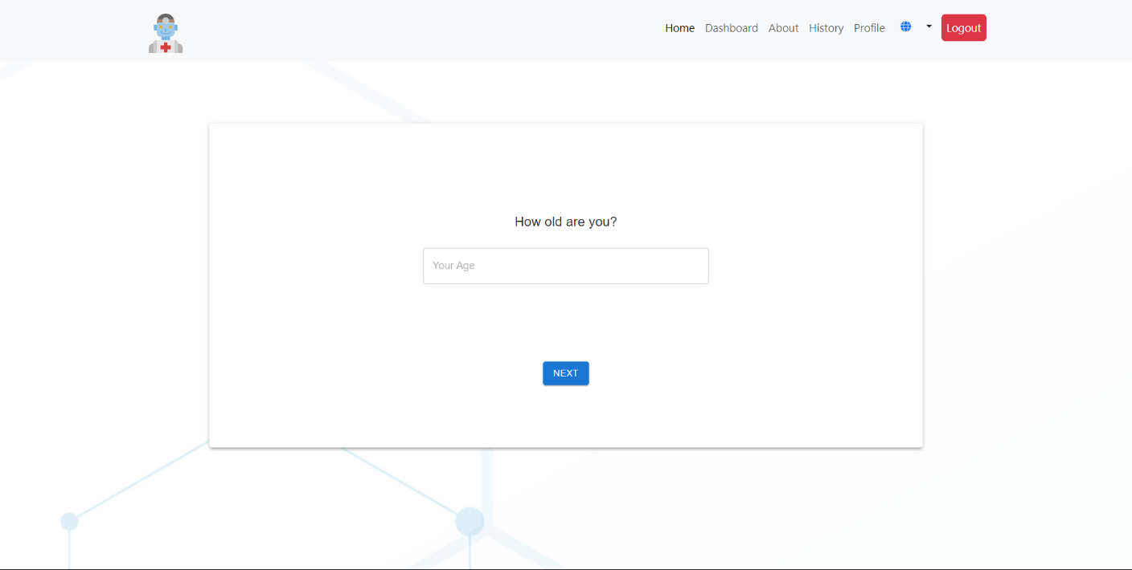

Figure 3.7.7: Test page UI

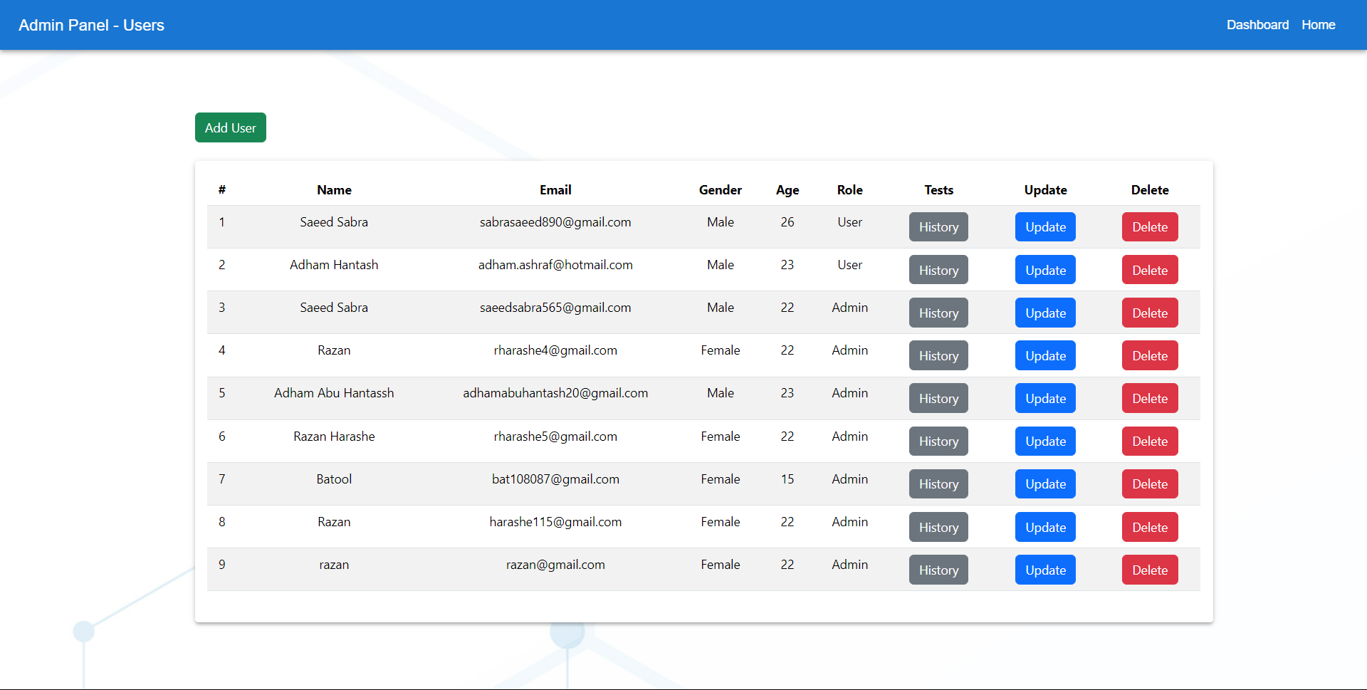

Figure 3.7.8: Admin page UI

# 

Figure 3.7.9: Add user page UI

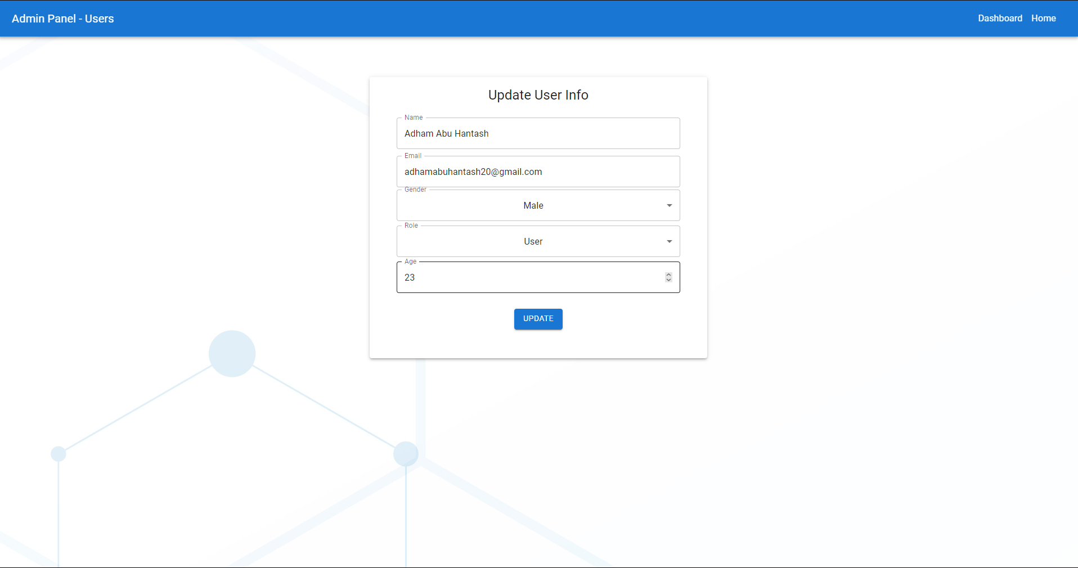

Figure 3.7.10: update user page UI

# 

Figure 3.7.11: Tests’ history page UI

# **References:**

1. <https://www.medindia.net/patients/calculators/blood-pressure-calculator.asp?fbclid=IwAR2qlQ_lxWw96WIh1RMMJ10HLfAhFyzSVZpAAZKeIT3xH79emOGeBbwxeaE>
2. <https://symptomate.com/ar/interview/5?fbclid=IwAR3URjTkkPKRDN0NLQtpJawlvCrywbUly0jkgqyF9CZ9_iDxoNJMWwV0AEs>
3. <https://www.nhs.uk/conditions/blood-pressure-test/?fbclid=IwAR3v6YpBvhfDRjsVUCL5iRBViJveZBIpXrbE_mPDpbc6m7Arm5pW-mG2jj0>
4. <http://www.beat-diabetes-calculator.com/>
5. <https://symptoms.webmd.com/>
6. <https://lucid.app/documents#/documents?folder_id=recent>
7. <https://www.w3schools.in/sdlc/agile-model?fbclid=IwAR3koH-ryeB3dCRpwcup7PfPVZxW9Ljl5cmCcuzbrChAo-yRPLI87nN9_sE>
8. <https://www.tutorialspoint.com/uml/?fbclid=IwAR2z1rJinaY2Xg9HR2qoNuW96NdIvu9bTRtSMFwghsOT8dZqfLEOgvOTszA>